Igor Oleshko
CSC 134
04/28/2022
Professor Sabzevary

OuterJoin

- Display the last name and the party description of each individual. If there is not a party associated with the individual then display “no party”
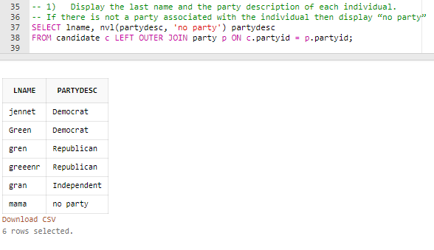

- Display the last name and the party description of each individual. If there is a party that does not have any individuals associated with it, then display “No one”
